Daniel Ingram-Brown’s visit to King James’s School on Monday 14th March
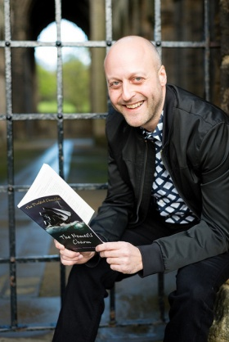
Daniel Ingram-Brown, author of Bea’s Witch and The Firebird Chronicles Series, will be visiting King James’s School on Monday 14th March. Come and meet him in the Library at breaktime, lunchtime or after school on Monday 14th March!

Daniel will be signing copies of his books at the visit. Your child can pay for their books on the day – just bring your completed form and money in a sealed envelope, or you can pay online, ahead of the visit and pick up the books up at school - just visit Daniel’s online shop https://dibrownauthor.square.site/. If you pay online, make sure you choose the ‘School visit pre-order’ option when checking out. Enter your child’s name and King James’s School. Your child can then collect their pre-ordered books at the visit. (If you would like your copies before the event, you can choose to have them delivered instead). Online pre-orders close at 12pm on Sunday 13th March.

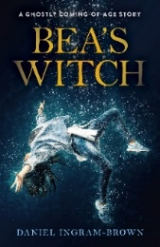
BEA’S WITCH: A GHOSTLY COMING-OF-AGE STORY £8 (RRP £8.99)
On the eve of her twelfth birthday, Beatrice Crosse runs away from her adoptive home only to encounter the ghost of England's most famous prophetess. The witch offers her treasure, but can she be trusted? Bea must wrestle her past to discover the witch’s secret and find her way home.
Suitable for ages 10+
“An enchanting story, beautifully written” P.J. Whiteley, Author & Journalist

The Firebird Chronicles:
Rise of the Shadow Stealers, The Nemesis Charm & Through the Uncrossable Boundary
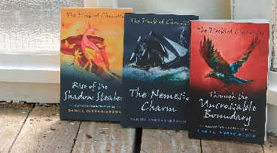
£7 each or reduced price of £18 for all three.
“A rollicking adventure!” Juno Magazine
“I was gripped...Fans of the Narnia books or Inkheart will love this.” State of the Arts
“Echo’s of C.S. Lewis” Rt Revd John Packer
Visit www.danielingrambrown.co.uk for more details.

Visit https://dibrownauthor.square.site/ to order your copies ahead of the visit or fill out the form below and bring it and the money in a sealed envelope on the day.
-------------------------------------------------------------------------------------------------------------------------

Name: ______________________________________________________

Form: _____________ Year:____________________

I would like to order (please tick):

- Bea’s Witch: A ghostly coming-of-age story (£8.00)
- Rise of the Shadow Stealers (£7.00)
- The Nemesis Charm (£7.00)
- Through the Uncrossable Boundary (£7.00)
- The Firebird Chronicles TRILOGY (£18)

TOTAL COST: _____________________

NB. CHEQUES SHOULD BE MADE TO ‘DANIEL BROWN’ NOT DANIEL INGRAM-BROWN

